CURRICULUM VITAE

PERSONAL DETAILS

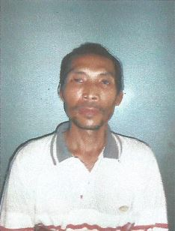
Name : Arip Martono
Place and Date of Birth : Jombang, February 14, 1977
Gender : Male
Nationality : Indonesian
Current Address : Sepinggan, Perum Melati Blok F1/20,
Balikpapan
Contact Number : 081312652809
Email Address : aripmartono1977@gmail.com

KEY SKILLS
TECHNICAL SKILLS
- NDT Inspection

CERTIFICATION & TRAINING
- MTPT Level I & II
- EMI
- Thickness Meausure Gouge
- Basic Inspection Techbology
- Use Drill Pipe Inspection
- Botton Hole Assembly
- Rig Component Inspection
- Magnetic Flux Leakage Level II

EDUCATION

- Senior High School, 1996, STM Dwija Bhakti Jombang

EMPLOYMENT

- INSPECTOR Level II
PT INSPEKTINDO SINERGI PERSADA
October 2019 – present

- Inspector Level II
PT Imeco Div Tuboscope
2015 – 2016
Location : Chevron PSB

- Inspector Level II
PT Imeco Div Tuboscope
2012 – 2015
Location : Apexindo Duta Pratama at Tuboscope Handil Yard

- Inspector Level I
PT Imeco Div Tuboscope
2008 – 2011
Location : Apexindo Duta Pratama at Tuboscope Handil Yard

- Helper
PT Imeco Div Tuboscope
2004 – 2008
Location : Baker Hughes Inteq Balikpapan

- Helper
PT Imeco Div Tuboscope
2000 – 2004
Location : Weatherford Balikpapan

- Helper
PT Imeco Div Tuboscope
1997 – 2000
Location : UNOCAL PSB

