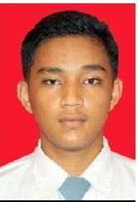
Personal information

Name |  | ARYA REIHAN
Profession |  | Operator Moulding Machine
Nationality |  | Indonesian
Place’ date of birth Jakarta 29 Oktober 2000
Education Sekolah Menengah Kejuruan (SMK)
OTOMOTIF
Address Bukit Tiban Selaras Blok C No 05 Batam Island Indonesia
Email address aryareihan29@gmail.com
Cell phone 088270921395
WA 085942342968

Key Qualifications |  | - Sekolah Menengah Kejuruan (SMK) BATAM-2018  - Training - PKL (Praktik Kerja Lapangan) -2017  - As mechanic in Bengkel Leman Mandiri. -2018 – 2019  - MT course -11 January 2021-16 January 2021  - PT course -30 Dec 2020-5 January 2021  PROFESSIONAL SUMMARY  - One {1} years Experience in Seal Manufacture

Work experience

Dates (from – to) |  | 2019 – 2020
Name and address of employer |  | End User : Vary
Occupation or position held  Main activities and responsibilities |  | Project : Vary  As Operator Moulding Machine To Make Rubber Silicone  In PT.KWONG FAI MANUFACTORY BATAM.  Seal manufacture .

