Name | Jefrizal Naldi | Date | 13/07/2022
Employee No. | ISP 21259 | Time | 12.13
Position | Inspector | Location | Cikarang
Control No: | *Leave this field empty, to be filled by the store person

Description of Equipment
Description |  | Serial Number / Asset Number |  | Type / Model |  | Manufacturer
Pembelian barang mess jaguar |  |  |  | - Mesin cuci  - Kulkas  - Rice cooker  - Kasur dan bantal  - Kursi meja untuk reporting
Description and cause of defect
describe the condition of malfunction, defective part, the circumstances under which its occurred and state the probable cause

kerusakan perabotan mess jabaeka karena banjir tinggi masuk ke rumah tahun 2021

Treatment
State the correction to stop the occurrence and recommendation to prevent recurrence

Penggantian perabotan mess yang rusak terkena banjir

Date of Checking | Remedial Action Require / Taken
 | Repair |  | Replace |  | Disposal/Scrap

Reported by | Reviewed by | Approved By : | Action by:
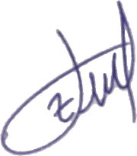
Name: Jefrizal Naldi | Name: | Name: | Name:
Date : 12/07/2022 | Date : | Date : | Date :

