DEFECT REPORT
Name | PAMBUDI KRISYANTO | Date | 17 MARET 2022
Employee No. | - | Time | 10.00 WITA
Position | COORDINATOR BALIKPAPAN AREA | Location | OFFICE FOIP
Control No: | *Leave this field empty, to be filled by the store person

Description of Equipment
Description |  | Serial Number / Asset Number |  | Type / Model |  | Manufacturer
CAMERA |  |  |  | IXUS 185 |  | CANON
Description and cause of defect
When I used the camera on the project PNEP at ETZOMER505 after taking some of picture the zooming lens cannot back in to camera, so that time I used fush the zooming lens manualy so it’s can get in

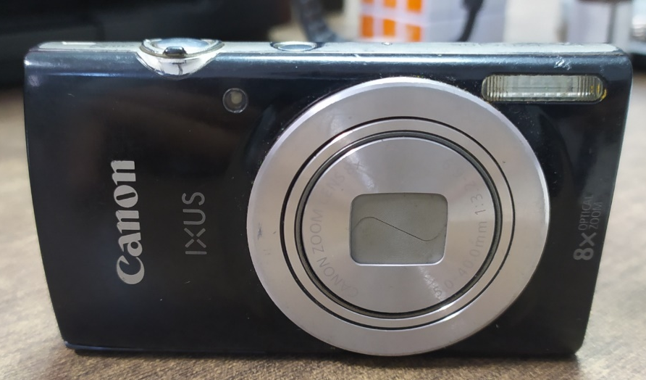
Treatment
Date of Checking | Remedial Action Require / Taken
 | Repair |  | Replace |  | Disposal/Scrap
28 jan 2022
Reported by |  | Reviewed by |  | Approved By : |  | Action by:
Name:PAMBUDHI KRISYANTO |  | Name: |  | Name: |  | Name:
Date : 17 MARET 2022 |  | Date : |  | Date : |  | Date :

